An Empirical Analysis of China’s Modern Nationalistic Boycotts and Financial Market

Author: Wenxuan Liu

**Abstract**

This research is aimed to evaluate the impact of China’s modern nationalistic boycotts on financial market, empirically based on past data and events including Diaoyu Island Conflict in 2012 and THAAD Deployment Issue in 2016. The main methodology is quantitatively evaluating China’s nationalistic boycotts’ influence on financial market by using synthetic control group method. To achieve this, numerous tools were used such as stock’s adjusted close price, Baidu Index, google trend, etc. Further, I developed an original equation to calculate the equal-weighted based on the database of 36 stocks’ adjusted close price for 1425 days. The result of this empirical research shows that China’s modern nationalistic boycott could temporarily depress boycotted companies’ stock values, especially for the companies selling consumer goods. However, this influence usually only lasts for less than three months.

Keywords: Nationalism, Boycott, Financial market, Price Index, Baidu Index, Original equation, international trade.

1. **Introduction**

Nationalistic boycott has long been an important political event in China after the foundation of the People’s Republic of China with its unique position on the international stage. For the recent few decades, its pros and cons are always debated intensively concerning social impact and national economics, especially when some international conflicts involving China occur. However, since the issue of nationalistic boycott is usually complex and not well-defined, the discussion and analysis usually are mixed up with numerous fields of study such as behavioral analysis and global commercial relationship.

In order to precisely focus on the study in this issue that fits the situation of China, it is important to define our study object. In this research paper, a boycott is defined as an act of voluntary and intentional abstention from using, buying, or dealing with a person, organization, or country as an expression of protest, usually for social, political, or environmental reasons. Nationalistic boycott, as one type of boycott, refers to the act that specifically aimed to urge other countries to apply or withdraw certain political actions concerning the interests of people’s own country.

An important question is what are the causes of a nationalistic boycott. According to the mainstream results of studies in the past, the reasons behind the nationalistic boycotts China are considered mainly related to three aspects. The first cause, which is also usually the most direct cause, is the recent political conflicts. In the past few years, China has met several international disputes concerning China’s basic interest and standpoint. For example, Japan’s controversial claim of the ownership of Diaoyu island and the one-way purchase of part of Diaoyu island in 2012 and South Korea’s deployment of THAAD in favor of assisting US’s expansion of military influence are the events which ignited Chinese public’s animosity. Thus, Chinese people tend to conduct boycotts against those countries in order to urge those countries’ governments to make certain concessions in disputes concerning China.

The second cause concerns nationalism in Chinese society. After having gone through WWII in the 1940s and 10 years of the Great Cultural Revolution in the 1970s, China has been greatly influenced by the ideology of nationalism. In recent years, this unique rooted ideology of Chinese people still has impacts on society which have led to boycotts against Japan’s and Korea’s products due to their history of animosity and cultural differences.

Last but not least, China’s economic status plays an important role in this issue. As the biggest importing country in the world, China’s commercial action plays a critical role in many countries’ economics. For example, China imported 144.68 billion dollars of Japan’s goods in 2012, which takes 18% of Japan’s annual amount of exports. Thus, China’s commercial action has a great influence on Japan’s economics.

Then, after the discussion of the causes, the positive and negative impacts of China’s nationalistic boycott should be concerned. On the bright side, a nationalistic boycott could impose negative reciprocity (punishment) on the boycotted countries, promote local people’s patriotism, and increase sales of native products; Meanwhile, it could also negatively affect China’s complement goods, cause negative public opinions from other countries and so on.

In general, the overall situation could be generalized into two concerns: whether or not the nationalistic boycott defeat Japan’s (South Korea’s) economics, and whether it defeat or promote China’s economics. Thus, a hypothesis could be formulated based on all the aforementioned conditions. In order to narrow down the discussion of which data could be precise and sufficient, the criterion of evaluating whole economics is focusing in one field: financial market. Therefore, a basic hypothesis of the result and corresponding significance is as followed:

|  |  |  |
| --- | --- | --- |
| Result of China’s nationalistic boycott | Defeat Japan’s(South Korea’s) financial market | Have little impact on Japan’s (South Korea’s)financial market |
| Defeat China’s financial market | Compare the cost | × (not worthwhile) |
| Have little impact on China’s financial market | √ (worthwhile) | Compare the side effect |
| Promote China’s financial market | √√ (very worthwhile) | √ (worthwhile) |

In this case, the aim of this research paper is to evaluate and quantify the impacts of China’s nationalistic boycotts on financial market on both sides and learn about the consequences of international conflicts.

The contributions that distinguish it from previous studies are manifold: firstly, this research include the most recent event that is THAAD Deployment issue in 2016 which was one of the most typical nationalistic boycott event in contemporary China; Secondly, the time determination method is more effective to choose the most relevant date related to the effects of boycott concerning both the media and public’s awareness with database from searching engine; Thirdly, the evaluation of impact of boycott is based on comparison of experimental group and the control group, which yields more accurate result without the influence of other major events in certain industry; Finally, there is an original equation developed to calculate the equal-weighted based on the database of 36 stocks’ adjusted close price for 1425 days.

The paper is organized as follows: Section II provides literature review about relevant past studies and background knowledge, while section III outlines the empirical implementation and important data. Section IV presents the analysis and results. Section V concludes.

1. **Literature Review**

While numerous researches have been done to analyze boycott’s cause and influence on trade market and social activities, the big picture of boycott in macro fields has been studied thoroughly. According to most research, boycotts created loss in both sides of the opposite countries. However, the impact on financial market has been vague with insufficient studies and limited apparent interrelationship.

Past studies on boycott model include*The animosity model of foreign product purchase: An empirical test in the People's Republic of China* by Jill Gabrielle Klein (1998), which analyzed the behavior of a customer when he is evaluating products from foreign countries. Researchers collected data from the census in China, asked relevant questions which formulate data (0.0 - 1.0) of the relevance of people’s animosity and their inclination of purchasing, and the result shows that animosity indeed plays an important role in consumer’s willingness of purchase. Further, *The boycott model of foreign product purchase: an empirical test in China* by Malcolm Smith and Qianpin Li (2011) suggests that there are significant and positive pairwise relationships between boycott participation and three factors (i.e. animosity, efficacy, and prior purchase), which further explains Klein and Jill Gabrielle’s result and offers new perspectives concerning economical cause and psychological cause.

Concerning financial market, relevant studies include *Financial Markets: A Tool for Social Responsibility?* by Matthew Haigh and James Hazelton (2004). This research discussed socially responsible investment (SRI*) with reference to the two main mechanisms of the SRI “movement”: shareholder advocacy and managed investments. The result turns out to be that company’s position and behavior involving social or political stake could indeed influence the corresponding stocks in financial market. Similarly, another basic study also provides supportive theories in the view of economics: *The Origin of Trade: Reciprocity, Hunter-Gatherer Sharing, and the Market Economy* by Vernon L. Smith. This research examines the history and model of reciprocity which supports the behavior of exchange. According to the article, there is positive reciprocity which encourages fair exchange as well as negative reciprocity which punishes unfair exchange.

In addition, studies involving the two major events in this research (Diaoyu island dispute in 2012 and THAAD Deployment issue in 2016) include *Trade Between Japan and China: Dramatic Expansion and Structural Changes* by Hitoshi Sasaki and Yuko Koga (2003). This article introduces the background of trade situation between China and Japan. Specifically, it illustrates that China increased its share from 5 percent to 10 percent in exports and from 12 percent to 18 percent in imports (1998-2002), which marks the beginning of China’s growing influence on Japan’s economics. In this article, the authors attribute the situation to three events: Self-sustaining growth in China’s economy, China’s accession to the WTO, and increase in foreign direct investment in China. Another important report dealing with THAAD issue is *China's Response to THAAD Deployment and its Implications* by Ethan Meick and Nargiza Salidjanova (2016). This report also provides tremendous amount of background information, and indicates that this issue did cause great loss to some industries related to consumer goods.

Last but not least, *Does Political Conflict Hurt Trade? Evidence from Consumer Boycotts* by Kilian Heilmann (2015) is a recent article that specifically discusses the impacts of consumer boycotts in economics. By using difference-in-differences regressions and the synthetic control group method, this research shows that boycotts can have strong negative effects on bilateral trade in both goods and services.

1. **Empirical Research**
2. **History Review**

In Chinese history, boycotts have occurred for numerous times since the 1920s. In this research, the empirical analysis is mainly focusing on two major nationalistic boycotts in the recent 5 years.

The first one is happened due to the Diaoyu Island Dispute against Japan in 2012. In September 2012, the Japanese government announced that they purchased the disputed islands between China and Japan, triggering large-scale protests in China. As of early February 2013, the situation has been regarded as "the most serious for Sino-Japanese relations in the post-war period in terms of the risk of militarized conflict."[1]

For at least half a year, mainstream media in China covered a tremendous amount of articles about this issue and people’s focus on the history of the intense relationship with Japan was drawn back to the public again. On one hand, people came to streets and smashed and destroyed the shops and products related to Japan like certain cars or electronic devices, which caused chaos and loss in local society; On the other hand, the Chinese public and the government stopped buying and importing the goods from Japan, which blocked the trade and economic development in Japan.

The second nationalistic boycott analyzed in this paper is against South Korea, involving the issue of THAAD (Terminal High Altitude Area Defense) Deployment in 2016. In July 2016, American and South Korean military officials agreed to deploy the THAAD missile defense system in the country to counter North Korea's growing threats and use of ballistic missile and nuclear tests. The Chinese government, however, concerned that deployment of THAAD in South Korea, despite being directed at North Korea, could jeopardize China's "legitimate national security interests."[2]

Consequently, there were fluctuations in financial market. According to previous research on consumer boycott, the incidence of consumer boycotts in contemporary China has resulted in a large number of foreign companies, and their products or services, being subjected to this disturbing problem. Consequently, many foreign multinational enterprises have suffered heavy losses, economically and politically, from Chinese consumer strikes.[3]

Thus, the main part of this research paper is conducted to evaluate the financial loss of enterprises in different industries of different countries. By quantitatively examining the actual loss with the experimental groups and the control groups of stocks, this research offers a new vision of the overall fluctuation with synthetic groups of stocks.

1. **Methodology**
   1. **Time Determination**
   2. Tool

In order to figure out the time period in which people commonly perceive the occurrence of nationalistic boycotts in China, keyword searching analysis tools including Baidu Index and Google Trend were used. Given that people that conducted nationalistic boycotts in China were usually triggered by the reports and articles online, and the boycotts would also cause people to search relevant events online, the amount of online searching and the amount of reports in the media could correspondingly illustrate the level of people’s attention on nationalistic boycotts, which is the indicator emphasizing the date of the public’s maximum awareness of political events.

* 1. Keywords

Baidu Index was used to formulate a big picture of the public’s attention, while google trend and Tencent Index was used to verify and adjust the result of Baidu Index. For boycotts against Japan in 2012, the keywords “钓鱼岛”(meaning “Diaoyu Island”) were used to measure people’s awareness of the nationalistic event by depicting people’s online searching behavior in Baidu index. Similarly, “乐天” (“Lotte”) and “萨德”(THAAD”) were used in the case of South Korea in 2016.

The reason why these words were chosen is that they are inclusive of basically all the potential research behavior concerning relevant events that could cause boycott. For example, while people are searching for Japan’s announcement of purchasing Diaoyu island or Japan’s radical claims of their ownership of Diaoyu island, the keyword “Diaoyu island” was used in all the situations, which would be counted into the index for this keyword, making the index more accurate and comprehensive.

* 1. Justification

In other relevant studies on China’s nationalistic boycott, the onset of boycott is usually considered on the date of major events happened such as Japan’s announcement of purchasing island (September). However, this determination has two drawbacks. The first one is that the relevant controversial events were usually happening continuously, which means boycott is not usually triggered by simply one major event; The second one is that it failed to concern the necessary time interval of sufficient spread of news and public’s reactions towards the events, which actually should have delayed effect in the perspective on time determination. In this case, measuring the popularity of relevant reports in the view of media and public is the way to more precisely reflect people’s awareness and willingness of participation in the nationalistic boycott.

1. **Financial Market**
   1. Method

Basically, the analysis in the financial market is based on a control test. By comparing the trend of price with stocks that were affected by China’s nationalistic boycotts and the ones that were not, we could formulate experimental group and control group. Further, in order to reflect the overall trend of each industry in each country, synthetic groups were constructed by combining certain groups together with an original price index calculation.

The reason why we should utilize the control group in which companies that were not affected by China’s nationalistic boycotts is that the fluctuation of price during the period of boycott event was not necessarily all caused by the boycotts. Potentially, there could be other major events happening during the same period of time which could affect the whole industry like global economic recession in 2012, presidential election in 2016 and so on. Thus, the control group could depict the basic trend of industry’s performance around the world, which makes the comparison to be much more precise and useful than simply looking at the performance of experimental group.

* 1. Stocks Selection

There are basically two types of groups: experimental group and control group. Since the main objects studied in this research are the companies influenced by China’s nationalistic boycotts, relevant companies in Japan, South Korea, and China are chosen to be experimental group; Contrarily, similar companies in other countries that were not influenced by China’s nationalistic boycotts were considered as control group.

Firstly, here is how experimental groups were formulated. In order to figure out the relevant stocks that could be influenced by China’s nationalistic boycotts, stocks were selected through the following process: Firstly, the rank of export and import of different types of goods from China is used to determine the main industries that could be seriously affected by nationalistic boycotts in China; Secondly, consumer goods are selected out from the rank, given that non-consumer goods are usually indifferent from the boycotts by the public; Thirdly, the top three companies in each targeted industry are chosen out by comparing the assets of the companies.

Secondly, control groups were selected in a similar way. In order to avoid the influence caused by nationalistic boycotts in China, the stocks in the control group are the ones which are among the top 10 companies in the corresponding industry and do NOT belong to Japan, South Korea, and China. Thus, they could reflect the overall trend of price in certain industries without the influence from boycott.

* 1. Original Index

Each index of different groups is calculated in an original equation:

By using Price Index () which demonstrates stock prices’ percentile in its own average price, the prices of stocks[4] are all calculated and transformed into a uniform index fluctuating around 1 (basically from 0.5 to 1.5). Thus, the trends of different stocks could be compared to each other with this index; Further, by combining of different stocks based on the third equation and formulating a synthetic index , the synthetic trend could be reflected without the different weights of stocks due to the difference in price. Thus, the trend of stocks’ prices of different industries in different countries could all respectively be reflected by the equal-weighted index .

Further, in order to more precisely analyze the impact, another index could be used to demonstrate the difference between experimental group and control group: Differential Price Index(DPI). DPI is calculated by using the Average Price Index(API) in control group to minus the API in experimental group. Thus, DPI directly depicts the loss of synthetic experimental group due to boycott.

1. **Results**
   1. Time Determination

Table 1: Nationalistic boycott against Japan (Diaoyu Island)

|  |  |  |  |  |  |  |  |  |
| --- | --- | --- | --- | --- | --- | --- | --- | --- |
| Country | Japan | | | | | | | |
| type | week | | | | date | | Aver |  |
| Date | 2012/8/25 | 2012/9/1 | 2012/9/8 | 2012/9/15 | up 2012/9/11 | max 2012/9/18 | Aver 2012/9 | Aver. 2012-14 |
| Baidu Index | 12918 | 63558 | 110857 | 1182677 | 1661488 | 1679741 | 619028 | 55258 |

Table 2: Nationalistic boycott against Korea (THAAD):

|  |  |  |  |  |  |  |
| --- | --- | --- | --- | --- | --- | --- |
| Country | South Korea | | | | | |
| type | week | | date | | Aver | |
| Date | 2016/7/18 | 2016/8/6 | up 2016/8/1 | max 2016/8/5 | Aver 2016/8-9 | Aver 2015-2017 |
| Baidu Index | 21691 | 53786 | 60841 | 63883 | 18947 | 2908 |

As shown in the chart, the result of “Diaoyu Island” in Baidu Index shows that the index begins rising up from 2012/9/11, when the index (1,661,488) was suddenly 30 times more than the average index between 2012 and 2014; Then, the index reaches its maximum (1,679,741) on 2012/9/18, which marks the onset and peak of boycott.

Similarly, we can see that the index concerning “THAAD” has a significant increase on 2016/8/1 and reaches its maximum on 2016/8/5, so we can also conclude that these are the important dates of China’s nationalistic boycott against South Korea due to THAAD issue.

In this case, we could consider the beginning of China’s nationalistic boycott on 2012/9/11 in the case of Japan, and on 2016/8/1 in the case of South Korea.

* 1. Stock Selection

According to the trade relationship between China and boycotted countries, certain industries were selected out due to their high status in trade market and the characteristics of consumer good: Electronic industry, automobile, and cosmetics. Then, after comparing the asset, popularity, and sales, three companies for each industry were chosen to formulate the groups as follow:

Table 3: Stock List for Empirical Research

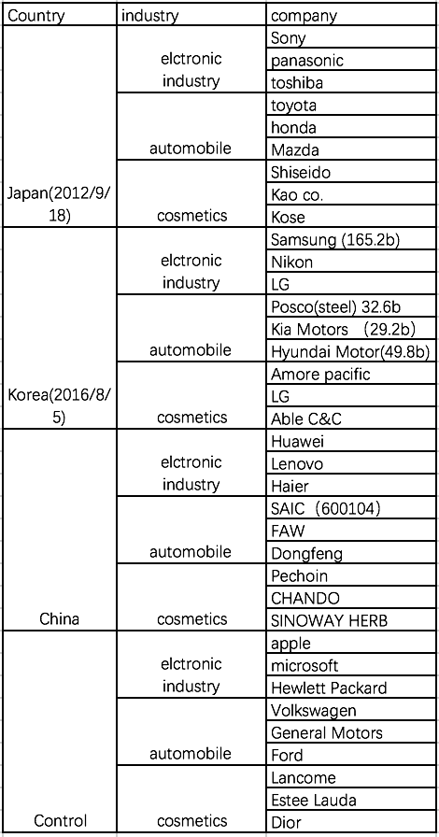[5]

1. Financial Market
   1. Overall evaluation

As shown in the Figure 5, 6, and 7, nationalistic boycott indeed has an impact on financial market. By looking at the deviation between experimental group and control group, we can see that the deviation usually happened immediately after the boycott, and reach its highest value a month later. This relatively low value would last for about half a year, and then would gradually regain its value accord with the control group.

Then, by looking at the fluctuation of DPI, we can find that in most cases, DPI would decrease about 0.2 within 3 months after the boycott, and then return to previous level or go randomly without further influence from the boycott.

* 1. Analysis in industries
     1. Automobile

Figure 1: Case Study Result for Japan in automobile industry

The stocks in automobile industry are the most representative ones because the effect of nationalistic boycott is shown obviously. Take the synthetic group of Japan for example. After boycott happened on 2012/9/11, the DPI of Japan’s group immediately increases from negative to positive on Sep 14, which means Japan group’s API intercepted the control group’s API and went down continuously. Further, the API of Japan’s group remained significantly below the API of the control group for about three months, which demonstrates that there is a lasting effect on financial market for a relatively long period of time. However, after three months, the loss gradually recovered. Similarly, South Korea’s performance when facing the boycott on Aug 1, 2016 was basically the same, with the API of Korea’s group remaining far below the API of the control group for a long time.

* + 1. Electronic Industry

Figure 2: Case Study Result for Japan and China in electronic industry

While the boycott usually devalues stocks in boycotted countries, it sometimes also enhances stocks in China. Electronic industry is a good example. In the chart above, we can clear see that after the boycott China’s stocks in electronic industry appreciate from 0.57 to 0.66 in 3 months, while the counterparts of Japan depreciate from 0.74 to 0.56 along with the control group. Similarly, other fluctuations of China’s stocks also show that the boycott has some positive influence on China’s native stocks, though not as effective as the negative influence on boycotted stocks.

* + 1. Cosmetics Industry

Figure 3: Case Study Result for South Korea in cosmetics industry

However, the aforementioned effects do not always occur. In the case of South Korea, the fluctuations sometimes only manifest limited correlation, especially in cosmetics Industry. As shown in the chart, while the control group basically remained at the same level after the boycott, the synthetic group of South Korea fluctuated without clear direction, though depreciated in the first week. This could be explained by the User Depiction result in Baidu Index.

Figure 4: Crowd Portrait of people concerning THAAD issue

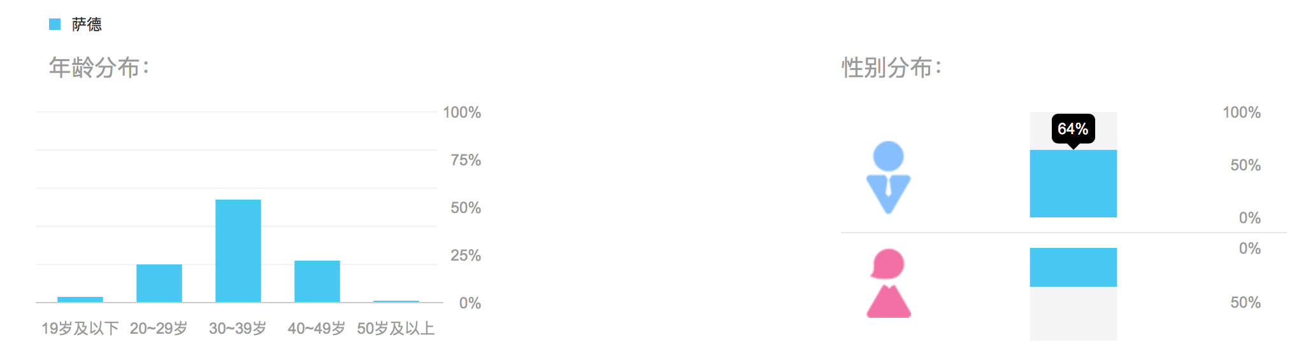[6]

While 64 percent of people who concerned THAAD issue are male and 54 percent are in their thirties, some industries mainly target at young and middle-aged female consumers would bear less negative impact. Further, since the THAAD issue was not as intensive and well-known as Diaoyu Island conflict in China according to the result of Baidu Index (1,679,741 for Diaoyu Island and 63,883 for THAAD issue), the less obvious testing result in South Korea’s stock market also verify that the influence of China’s nationalistic boycott proportionally matches the loss of boycotted companies in stock market.

1. **Conclusion**

After the examination of the overall fluctuation in the stock market in the studied countries caused by China’s nationalistic boycott, we can draw out a game theory:

|  |  |  |
| --- | --- | --- |
| China’s nationalistic boycott / boycotted country’s Concession | Yes | No |
| Yes | Target situation | Ideal situation |
| **No** | Interim situation | Original situation |

Given that the nationalistic boycott is an economical activity concerning complex causes and impacts, the situation of the boycott is always evolving based on the strategies taken by each side with the weighing of the pros and cons in different perspectives. In this case, theoretically there is an optimum strategy for China based on considerations of Japan’s strategy. However, since the process of the game analysis is unremitting with multiple factors in the outcomes, it is basically irregular in this chaotic system, which always makes it difficult for people and the government to make the right decisions.

However, this research shows that the boycott result always turns out to be in the interim situation without moving into target situation in the end. Then, this situation would temporarily bring loss to financial market to boycotted countries and maintain or slightly promote native industries in China in a short term (more than one month and less than three months), while the influence would not last for more than three months. Specifically, the boycotts against consumer goods such as automobile and electronic devices could be more effective.

Hence, China’s modern nationalistic boycott is effective in the view of economics. Though the boycott does not have significant positive or negative long-term influence, it could bring loss to the boycotted countries temporarily, which could impose negative reciprocity(punishment) on foreign countries. Thus, China’s nationalistic boycott could be conducted in the contemporary world during a political conflict in economic perspective.

Acknowledgements

I would like to thank Prof C. Fohlin for her helpful instruction during my research project, and thank Mr. Kevin, Stanley Wang, Maggie Jiang, and Georgia McKirgan for their valuable suggestions.

**Appendix**

1. Time determination

Figure 5 to Figure 8: Result of Baidu Index

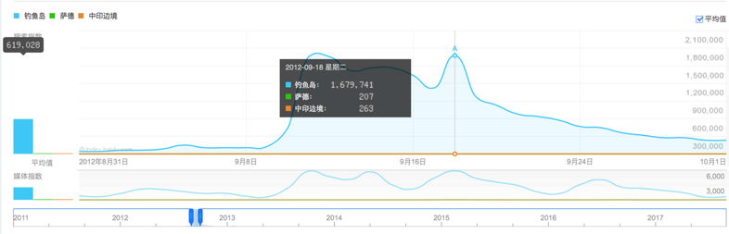

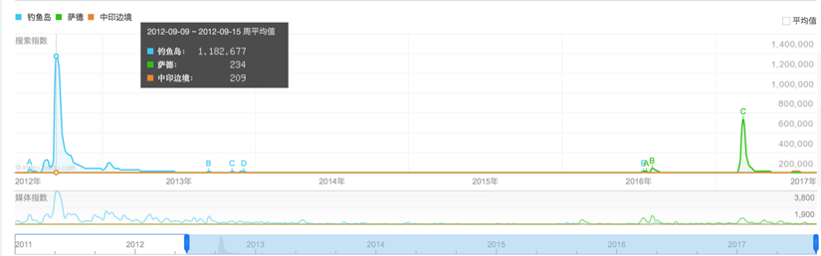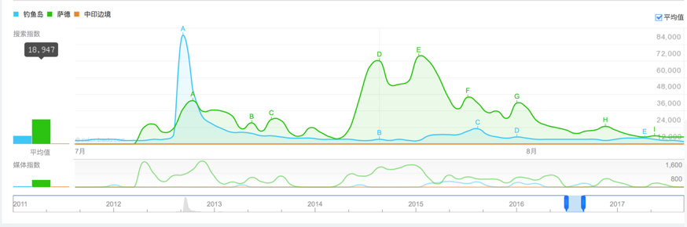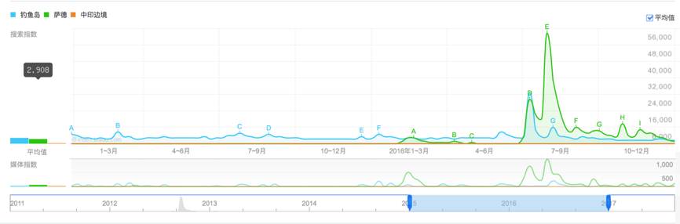[7]

1. Stock Selection

Table 4: The calculation of Import and Export of different countries

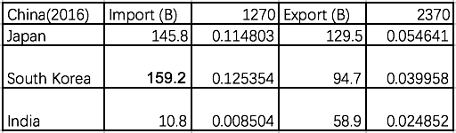[8]

Table 5: Rank of goods Imported to China

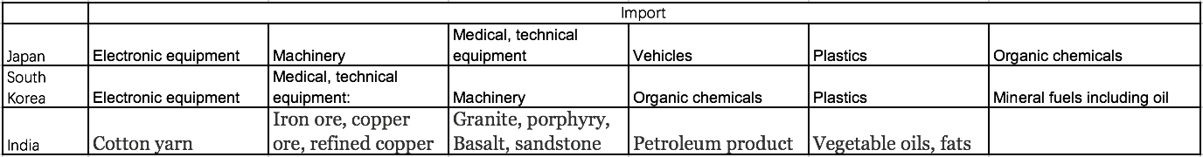

Table 6: Rank of goods Exported from China

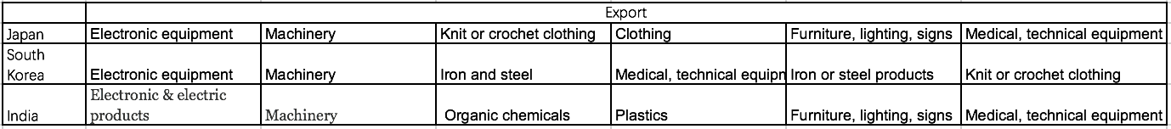

1. Financial Market

Figure 5: Overall performance in Automobile Industry

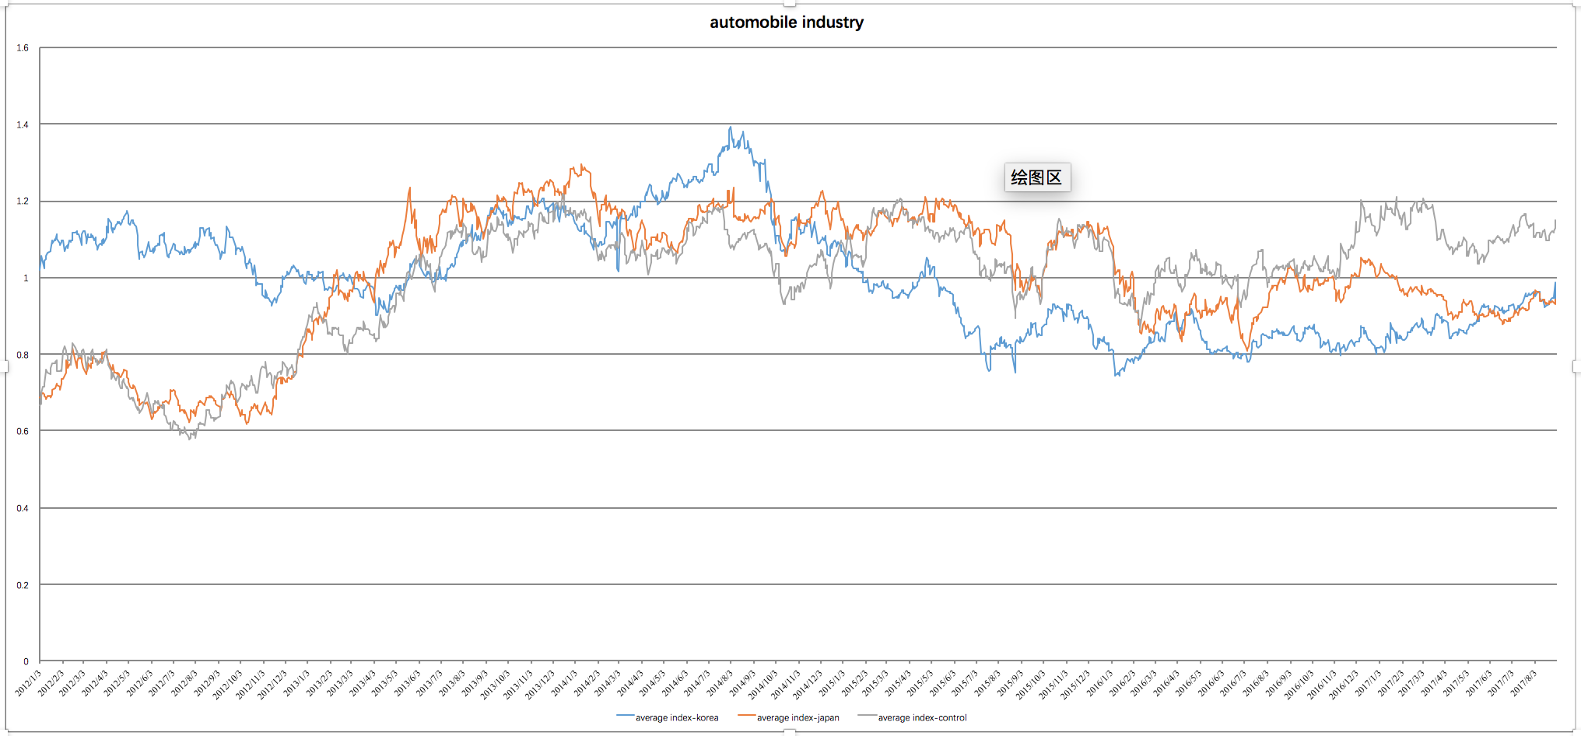[9]

Figure 6: Overall performance in Electronic Industry

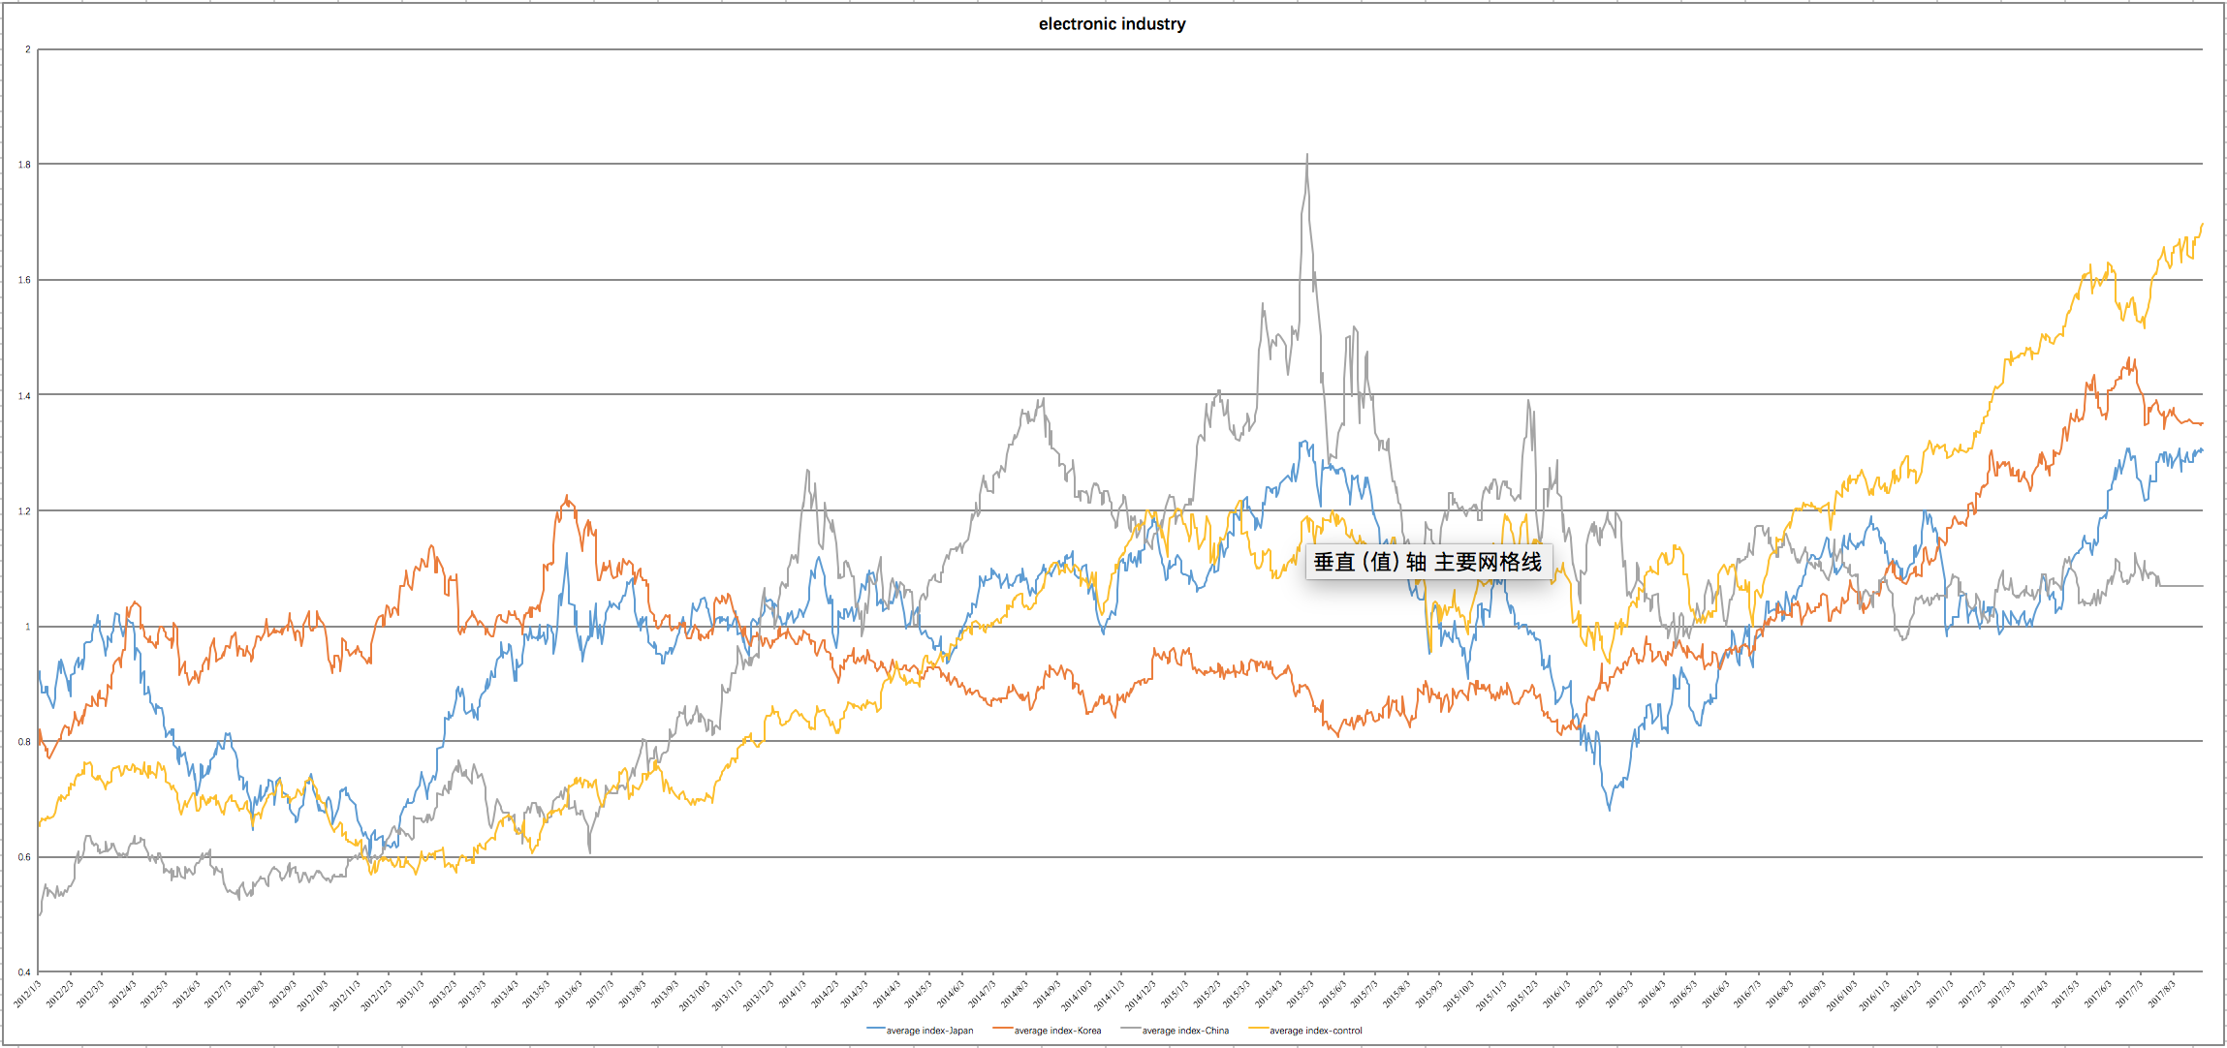

Figure 7: Overall performance in Cosmetics Industry

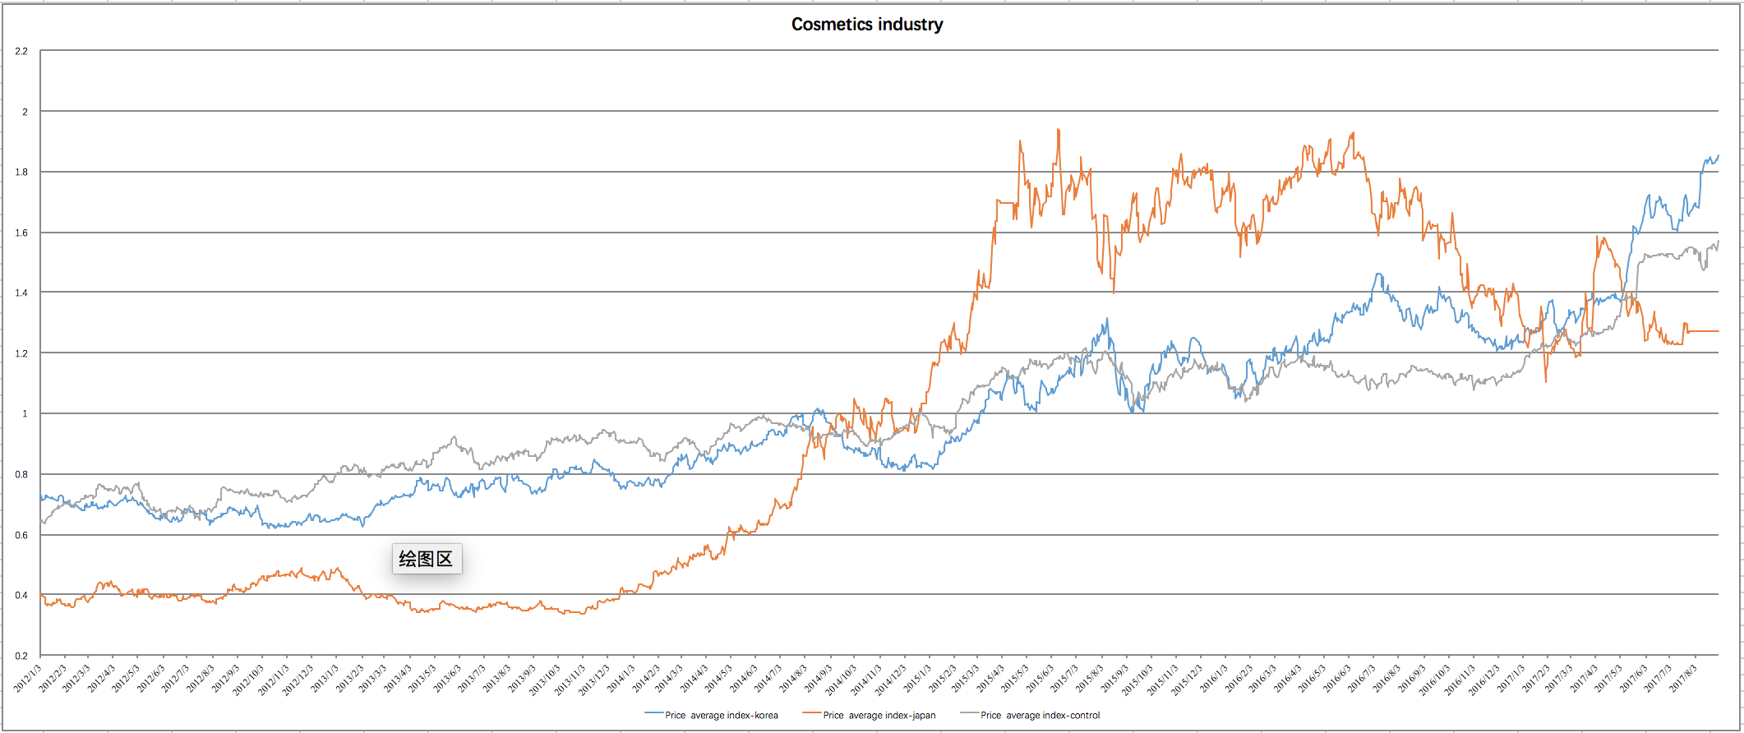

Table 7: API in Case Study for analysis of Japan

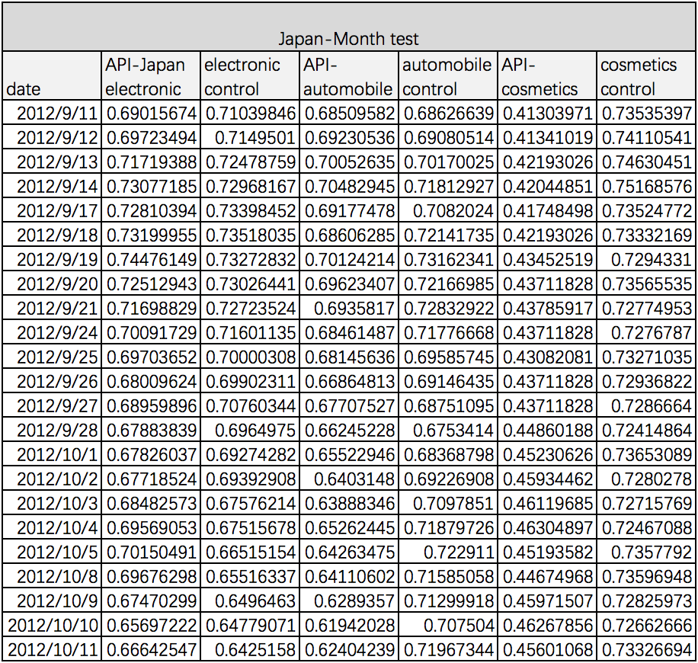

Table 7: API in Case Study for analysis of South Korea

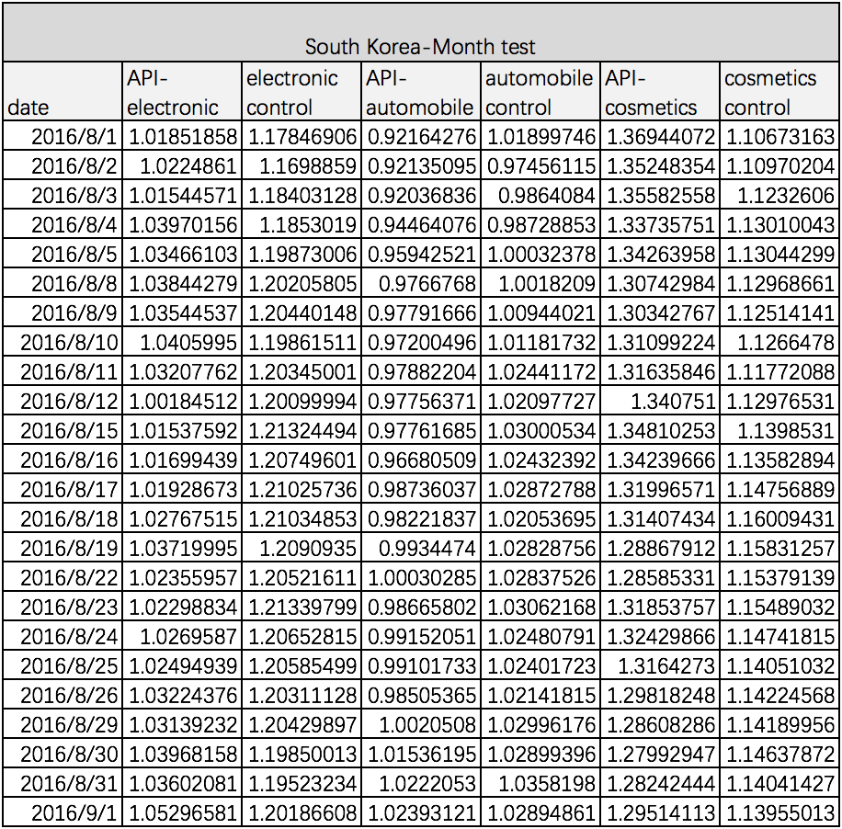

**Bibliography:**

Hitoshi Sasaki & Yuko Koga (2003), Trade Between Japan and China: Dramatic Expansion and Structural Changes, Bank of Japan Review Series, <https://ideas.repec.org/s/boj/bojrev.html>

Armstrong, Shiro Patrick. “Interaction Between Trade, Conflict and Cooperation: The Case of Japan and China.” *SSRN Electronic Journal*, 2010, doi:10.2139/ssrn.1767659.

 Kai, Jin. “What THAAD Means for China's Korean Peninsula Strategy.” *The Diplomat*, The Diplomat, 28 July 2017, thediplomat.com/2017/07/what-thaad-means-for-chinas-korean-peninsula-strategy/.

“What Happened to Japan's Electronic Giants?” BBC News, BBC, 2 Apr. 2013, www.bbc.com/news/world-asia-21992700.

Armstrong, Shiro Patrick. “Interaction Between Trade, Conflict and Cooperation: The Case of Japan and China.” *SSRN Electronic Journal*, 2010, doi:10.2139/ssrn.1767659.

 “China’s Top 10 Imports.” *World's Top Exports*, 3 Apr. 2017, www.worldstopexports.com/chinas-top-10-imports/.

“近现代中国爱国主义思潮的历史趋势.” *近现代中国爱国主义思潮的历史趋势_CNKI大成编客*, bianke.cnki.net/Web/Article/BJSK502.035.html.

Fishman, Raymond, Yasushi Hamao, and Yongxiang Wang (2014): Nationalism and Economic Exchange: Evidence from Shocks to Sino-Japanese Relations, NBER Working Paper No. 20089.

"Economic Policy Uncertainty Index." Economic Policy Uncertainty Index. Accessed September 20, 2017. <http://www.policyuncertainty.com/>.

"China has the most leverage on Kim Jong-un's regime. Will it use it?" Council on Foreign Relations. Accessed September 20, 2017. <https://www.cfr.org/backgrounder/china-north-korea-relationship>.

"Trade Between Japan and China:Dramatic Expansion and ..." Accessed September 20, 2017. <https://www.bing.com/cr?IG=33F080C507294D7FB97CAF3C3C1D69E2&CID=08052AC960E86E1B36D521CA61EE6FEE&rd=1&h=W7a2tYP7b3THdrst5ERnc_aQTftbl1bhm90bJM0nLmI&v=1&r=https%3a%2f%2fideas.repec.org%2fp%2fboj%2fbojrev%2f03-e-3e.html&p=DevEx,5063.1>.

Smith, Malcolm, and Qianpin Li. "The boycott model of foreign product purchase: an empirical test in China." Asian Review of Accounting 18, no. 2 (2010): 106-30. doi:10.1108/13217341011059381.

Klein, Jill Gabrielle, Richard Ettenson, and Marlene D. Morris. "The Animosity Model of Foreign Product Purchase: An Empirical Test in the Peoples Republic of China." Journal of Marketing 62, no. 1 (1998): 89. doi:10.2307/1251805.

Heilmann, Kilian. "Does political conflict hurt trade? Evidence from consumer boycotts." Journal of International Economics 99 (2016): 179-91. doi:10.1016/j.jinteco.2015.11.008.

Haigh, Matthew, and James Hazelton. "Financial Markets: A Tool for Social Responsibility?" Journal of Business Ethics 52, no. 1 (2004): 59-71. doi:10.1023/b:busi.0000033107.22587.0b.

"Economic Policy Uncertainty Index." Economic Policy Uncertainty Index. Accessed September 20, 2017. http://www.policyuncertainty.com/.

"China’s Response to U.S.-South Korean Missile Defense ..." Accessed September 20, 2017. https://www.bing.com/cr?IG=C655927D432F47E0BE0E9022AEF0D432&CID=3E691724EAAA6E331BB71C27EBAC6F03&rd=1&h=hA32of0suZE4iHBsbVhCG2hCHVgk_fDNtHEnzeFR8tw&v=1&r=https%3a%2f%2fwww.uscc.gov%2fsites%2fdefault%2ffiles%2fResearch%2fReport_China%2527s%2520Response%2520to%2520THAAD%2520Deployment%2520and%2520its%2520Implications.pdf&p=DevEx,5061.1.

1. Cited from *Breaking news on East China Sea disputed island* (2013)
2. Cited from *China's Response to THAAD Deployment and its Implications* by Ethan Meick and Nargiza Salidjanova (2016)
3. Cited from *Does Political Conflict Hurt Trade? Evidence from Consumer Boycotts by Kilian Heilmann* (2015)
4. Note: the adjusted prices sometimes are unavailable in the historical data in Yahoo Finance, so some null data were replaced with the median of two close date, which are marked red in the database.
5. Justification: While most of the historical data (adjusted close price) are available in Yahoo Finance, some stocks are not found in the cosmetics industry (Kose, LG, Lancome, and Cosmetics stocks in China group), so their trend are not used in the database for analysis.
6. The Crowd Portrait result of Baidu Index with the keyword “萨德” (meaning “THAAD issue”).
7. The searching result of Baidu Index, while the blue area represents Diaoyu Island (boycott against Japan), green area represents THAAD (boycott against South Korea).
8. summarized from *Worlds Richest Countries* http://www.worldsrichestcountries.com/top_china_imports.html
9.